ARRANGING SERIES OF NUMBERS BY IMPLEMENTING MERGE SORT

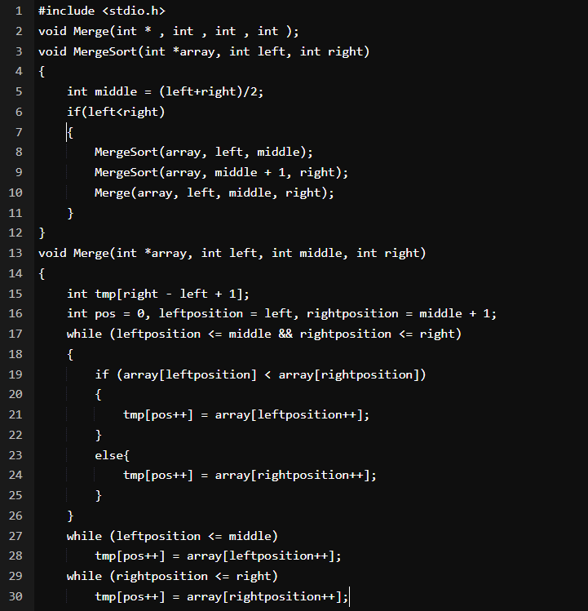

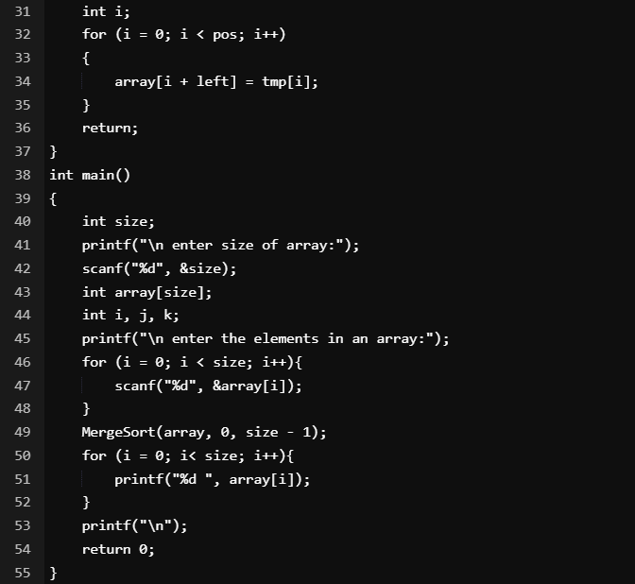

OUTPUT:

